

ICL-2011 Visualisation and Graphical Algorithms
TOBY BEEVERS
Cambria ID: 21075206 Bangor ID: 500704883
APPLIED DATA SCIENCE DEGREE APPRENTICESHIP BSC

Contents
Format and design for the holding page 2
Interactive Bar Chart 2
Interactive Pie Chart 2
Why Use Both Visualisations Together 3
Design and Accessibility Considerations 3
Holding Page Design Mock-up 3
Web page using HTML, JavaScript and Canvas 4
Why Chart.js? 4
Implementation Highlights 4
HTML Head 4
CSS Styles 5
HTML Body 5
JavaScript Structure 5
Task 1: Main Function to Start Visualisation 5
Task 2: Load and Parse CSV Data 5
Task 3: Create the Bar Chart 5
Task 4: Create the Pie Chart 6
Task 5: Set Up Interactive Controls 7
Task 6: Start Visualisation on Page Load 7
Justify your final design 8
Bibliography 9
Glossary 10
Document Object Model 10
HTML Code – index.html 10
Java Script Code – script.js 11
Final Dashboard 17

Format and design for the holding page
The objective of this assignment is to present 20 years of sales data in a way that is clear, engaging, and insightful for a diverse audience. To achieve this, I have selected a bar chart and pie chart, which together provide both a temporal and categorical view of the data.

Interactive Bar Chart
Ideal for showing changes over time when comparing values across years. I chose an interactive bar chart for:
- Comparative Clarity: Users can compare sales data, with each bar representing a discrete year. Allows for easy identification of sales periods, trends, or drops in the market.
- User Engagement and Control: By including interactivity like toggles for regional data and sliders for year ranges, users can filter data based on interests, reducing cognitive overload by focusing only on information.
Additionally, bar charts accommodate large datasets more effectively than line graphs when the audience needs to focus on absolute values rather than continuous trends. The vertical layout is also more accessible for mobile-first designs, which is increasingly important given modern browsing habits [1].
The Sales dataset shows various types (segments) over time, I intend to analysis over a time series and include the following features:
- X-axis: Years (1980–2023)
- Y-axis: Total global sales (in millions)
- Interactive filtering (e.g., toggle between regions: NA, EU, JP, Other)
- Hover effects to display exact sales figures

Interactive Pie Chart
Complements the bar chart offering a proportional breakdown of sales by genre within a selected year. This provides categorical insight that would be harder to read in a bar format.
- Intuitive Understanding: Pie charts are immediately understandable, making them effective for conveying relative market share of game genres without needing analytical skills.
- Contextual Insight: Allowing users to select years via a dropdown menu, this chart reveals how genre popularity has shifted over time. This can identify broader trends, such as the rise of mobile games.
To enhance usability and data clarity, each slice will be colour-coded and labelled with percentages. An interactive legend will allow users to toggle genres on or off, helping to focus on specific segments [2].
The Sales dataset shows various types (Segments) over time, I intend to group by types and visualise in a pie charts showing proportions of sales, as a whole and filter by a given year. Features will include:
- Dropdown to select a year
- Breakdown of sales by segment (Sales Genre)
- Labels showing percentages

Why Use Both Visualisations Together
Using both visualisations provides a dual-perspective analysis:
- Bar chart gives a macro-level overview of sales over time.
- Pie chart offers a micro-level analysis of genre composition in a given year.
This approach caters to different user goals. A marketing analyst might use the bar chart to assess performance over time, while a developer might use the pie chart to gauge the popularity of a specific genre in a given market year.

Design and Accessibility Considerations
- Colour Choices: Will be selected using accessible palettes ensuring readability. High contrast and tooltips could assist screen readers.
- Responsive Design: The layout will be mobile-friendly, and could use scalable SVG graphics or chart libraries like Chart.js or D3.js.
- User Interaction: The ability to filter, hover, and drill down makes the visualisation more engaging and less static, providing a better user experience.

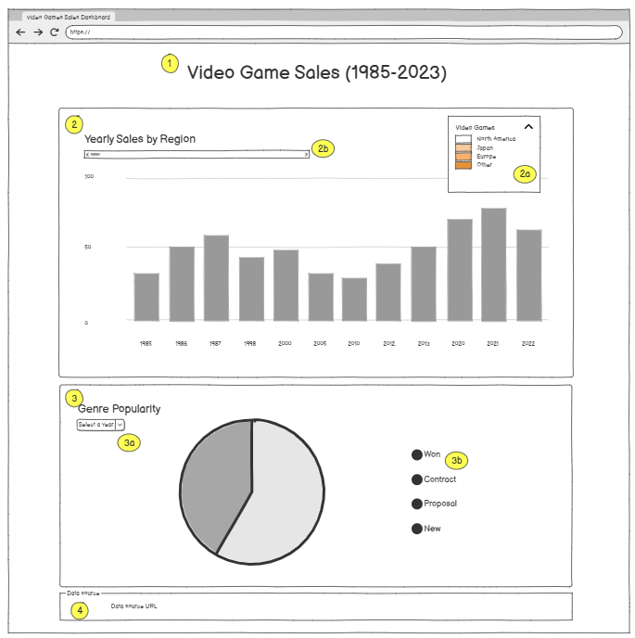
Holding Page Design Mock-up
A simple HTML page with:
- Header: "Video Game Sales (2003–2023)"
- Bar Chart Section:
  - Select filter by region
  - Horizontal slider to filter out time series
- Pie Chart Section:
  - Year selector dropdown menu
  - Legend for segments, with filter
- Footer: Data source attribution

Web page using HTML, JavaScript and Canvas
For this project, I have chosen to use JavaScript in combination with Chart.js to create dynamic, interactive data visualisations rendered on an HTML5 <canvas> element.
JavaScript is the foundation of modern web interactivity and is most suitable for client-side data visualisation for the following reasons:
- Browser Compatibility: Runs natively in all major browsers without requiring plugins, ensuring visualisations are accessible to a wide range of devices [4].
- Interactivity and Event Handling: Supports interactive features such as hover effects, click events, filtering, and dynamic updates. This is crucial for my project, users can toggle between regions and years or filter data by category [5].
- DOM Manipulation: Allows integration with HTML elements, such as dropdowns and sliders, enabling interaction with visual elements [6].
- Reusable Functions and Data Structures: Modularise code for drawing charts, updating data, and applying filters. Arrays and objects are used to manage and pass datasets between functions.

Why Chart.js?
I selected Chart.js as the primary library for several reasons:
- Ease of Use and Clean Syntax: Abstracts much of the complexity in drawing and scaling canvas-based charts. API is well-documented, allowing professional-looking visualisations quickly and efficiently.
- Support for Multiple Chart Types: Supports a range of chart types, enabling creation of visual styles without switching libraries.
- Responsive and Mobile-Friendly: Automatically adjusts to screen size, ideal for multi-device support. Important as the assignment requires the visualisations to be effective on a variety of devices.
- Interactive Features: Built-in tooltips, animations, and hover effects enhance user engagement. These features are built into Chart.js, reducing the need for custom coding.
- Canvas-Based Rendering: By using the <canvas> element, Chart.js offers smooth, high-performance rendering of graphics even when data volumes increase, without overloading the DOM.

Implementation Highlights
This section focused on some of the key parts of the code which we have not previously explored in other course modules.

HTML Head
Within the head I have used the Chart.js library [7]. The src attribute points to a Content Delivery Network, allowing use of libraries without downloading locally to code [8].
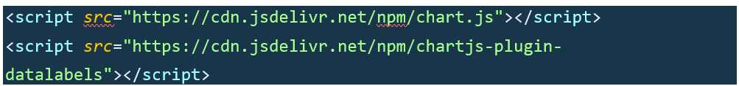

CSS Styles
CSS elements are within the index.html file purely for simplicity and the limited amount of code required. I have defined these class selectors used within the HTML Body elements, allowing for the reuse of code across multiple classes.
Defined CSS ID Selectors; indicated by the # prefix. Used in a similar way to the above Class Selectors, ID Selectors apply styles in single HTML elements that have the attribute.


HTML Body
The body has two containers that inherit the CSS Styling, the <canvas> element is used to render the relevant feature using the Chart.js library. The id="xxx" uniquely identifies the canvas, allowing JavaScript to target the correct container and render the chart.


JavaScript Structure
This section is broken down into the tasks the code is performing, I have referenced this within the code comments available in the glossary.

Task 1: Main Function to Start Visualisation
Start Visualisation is the main entry point of the program, loads the data using the loadGameData function, checks if the data is valid and then creates the charts.

Task 2: Load and Parse CSV Data
Creates a function to prepare the data to populate the visualisations, sets constant variables to fetch the CSV file and parses the content. For loops through the CSV and splits the data into rows and columns, before returning the data to an array of game objects, each containing sales data for different regions and globally.

Task 3: Create the Bar Chart
Creates the Stacked Bar Chart by For looping through the data from task 2 above, from here we start to use the Chart.js library API and assign the values to the dataset. I have chosen to use the default chart settings but have changed to colours for accessibility [9] [10].
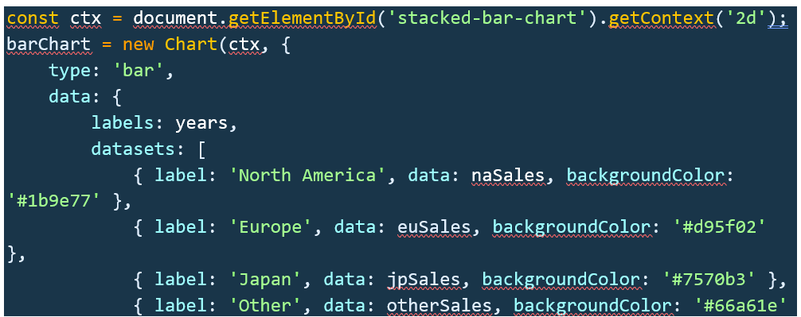

Task 4: Create the Pie Chart
Creates the Pie Chart from the data in task 2 above and Groups By Genre into a constant variable. The Pie Chart uses the data in a similar way, but I have changed the default options here to show fixed percentage values [10] [11].
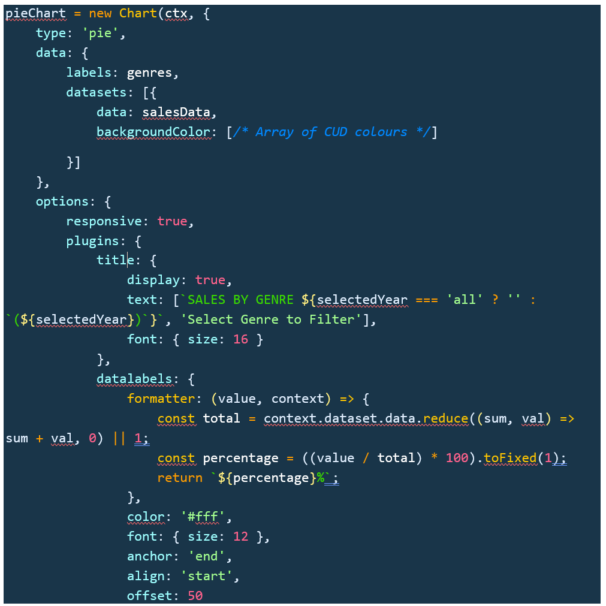

Task 5: Set Up Interactive Controls
Creates two interactive controls, a Slider Bar for the Stacked Bar Chart, a dropdown menu for the Pie Chart. To begin the For Loop collects and store the Years, I have then used Event Listers [12] to refresh the visuals as the user make the changes on the inputs. A native element of the Chart.js library allows the user to select either Region or Genre and exclude data from the legend [13].

Task 6: Start Visualisation on Page Load
The final line of code attaches an event listener to the window object, specifically listening for the DOMContentLoaded event [12] [5].
This event triggers once the initial HTML has been fully loaded and parsed, but before other resources like images, stylesheets, and external scripts have finished loading. By doing this, it ensures that the DOM (Document Object Model) is fully prepared for any interactions or modifications. This approach prevents potential errors that could occur if the script attempts to access DOM elements such as chart containers or controls before they exist.

Justify your final design
The final design of this dashboard was driven by the need to present 20 years of video game sales data in a way that is both informative and accessible to a wide audience, including non-technical users. The choice of an interactive stacked bar chart and a pie chart was made to balance temporal trends with categorical insight, ensuring users could explore patterns in sales both across time and by genre.
The stacked bar chart was selected to effectively communicates change over time and allows users to see the contribution of each region to global sales. Interactivity through the year slider enhances user engagement, while stacking makes regional comparisons intuitive without cluttering the chart. I intentionally used distinct, colourblind-friendly colour schemes to ensure accessibility, referencing ONS guidance on colour use in charts [3].
The pie chart complements this by enabling focused exploration of genre popularity within selected years. By grouping sales by genre and allowing filtering by year, the chart offers a snapshot of market trends in specific periods. This dual-visualisation strategy ensures that users can look both broadly (bar chart) and deeply (pie chart) into the data.
Chart.js was chosen for its ease of use, mobile responsiveness, and built-in interactivity. The library simplifies rendering and managing canvas-based charts, and allows for tooltip integration, legends, and data filtering with minimal additional code. This was critical to ensuring smooth user experience across devices, especially as modern users often access dashboards via tablets and phones.

Bibliography
[1] np., ‘Bar charts’, Analysis Function. Accessed: Apr. 28, 2025. [Online]. Available: https://analysisfunction.civilservice.gov.uk/support/communicating-analysis/introduction-to-data-visualisation-e-learning/module-5-bar-charts/
[2] np., ‘Pie Charts’, Analysis Function. Accessed: Apr. 28, 2025. [Online]. Available: https://analysisfunction.civilservice.gov.uk/support/communicating-analysis/introduction-to-data-visualisation-e-learning/module-9-pie-charts/
[3] ONS, ‘Using colours in charts’, ONS Service Manual. Accessed: Apr. 28, 2025. [Online]. Available: https://service-manual.ons.gov.uk/data-visualisation/colours/using-colours-in-charts#:~:text=with%20an%20order-,Overview,highlight%20data%20within%20a%20chart.
[4] np., ‘What is JavaScript, and why is it important?’, Big Commerce Essentials. Accessed: Apr. 30, 2025. [Online]. Available: https://www.bigcommerce.com/glossary/javascript/
[5] np., ‘JavaScript HTML DOM Events’, w3schools. [Online]. Available: https://www.w3schools.com/js/js_htmldom_events.asp
[6] np., ‘JavaScript HTML DOM’, w3schools. Accessed: Apr. 30, 2025. [Online]. Available: https://www.w3schools.com/js/js_htmldom.asp
[7] np., Chart.js Integration API. (np.). [Online]. Available: https://www.chartjs.org/docs/latest/getting-started/integration.html
[8] np., ‘Awesome Chart.js’, Github, np., Accessed: Apr. 30, 2025. [Online]. Available: https://github.com/chartjs/awesome#integrations
[9] np., ‘Bar Chart’, Chart.js. Accessed: Apr. 30, 2025. [Online]. Available: https://www.chartjs.org/docs/latest/charts/bar.html
[10] np., ‘Options’, Chart.js. [Online]. Available: https://www.chartjs.org/docs/latest/general/options.html
[11] np., ‘Doughnut and Pie Charts’, Chart.js. Accessed: Apr. 30, 2025. [Online]. Available: https://www.chartjs.org/docs/latest/charts/doughnut.html
[12] np., ‘JavaScript HTML DOM EventListener’, w3schools. [Online]. Available: https://www.w3schools.com/js/js_htmldom_eventlistener.asp
[13] np., ‘Step-by-step guide’, Chart.js. [Online]. Available: https://www.chartjs.org/docs/latest/getting-started/usage.html

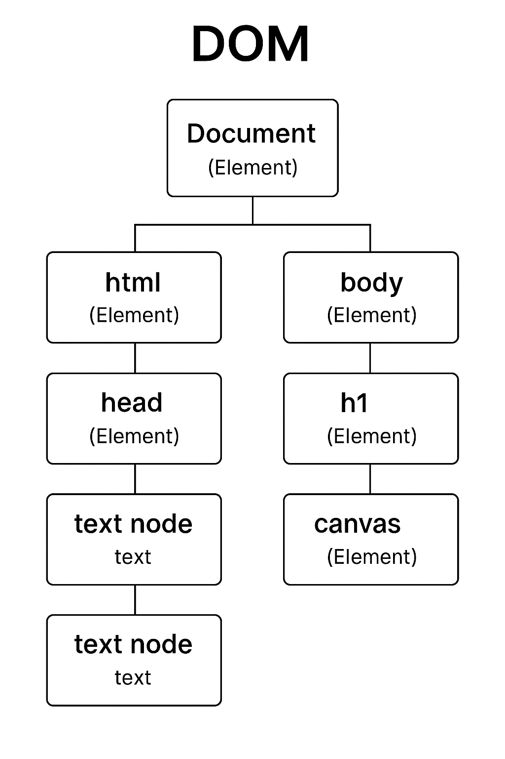
Glossary

Document Object Model
DOM stands for Document Object Model [6], it is a programming interface that represents the structure of a web page as a tree of objects, which browsers create when they load HTML and CSS. The DOM allows JavaScript to interact with and manipulate the content, structure, and style of a web page, every element in HTML (<div>, <canvas>, <h1>, or <button>) becomes a node in the DOM tree.

HTML Code – index.html
<!DOCTYPE html>
<html lang="en">
<head>
<!-- Specifies the character encoding for the document -->
<meta charset="UTF-8">
<!-- Ensures the page is responsive and scales properly on different devices -->
<meta name="viewport" content="width=device-width, initial-scale=1.0">
<!-- Sets the title of the webpage -->
<title>Video Game Sales Dashboard</title>
<!-- Includes the Chart.js library for creating charts directly from the CDN-->
<script src="https://cdn.jsdelivr.net/npm/chart.js"></script>
<script src="https://cdn.jsdelivr.net/npm/chartjs-plugin-datalabels"></script>

<style>
/* Sets the default font and layout for the body text */
body { font-family: Arial, sans-serif; margin: 0; padding: 20px; }
/* Sets the default font and layout for the main heading */
h1 { text-align: center; }
h2 { text-align: right; margin: 10px 0; }

/* Sets the default chart container to centre it and set width constraints */
.chart-container {
margin: 20px 0;
width: 50%;
max-width: 1000px;
margin: 0 auto;
}
/* Styles for the control elements like sliders and selectors */
.controls { margin: 10px 0; }

/* Sets a fixed height for the stacked bar chart */
#stacked-bar-chart { height: 400px; }
/* Sets a fixed height for the doughnut chart */
#doughnut-chart { height: 150px; }
/* Sets the width of the year slider */
#year-slider { width: 500px; }
</style>
</head>

<body>
<!-- Main heading of the dashboard, using CSS h1 -->
<h1>Video Game Sales (1985-2023)</h1>

<!-- Container for the stacked bar chart -->
<div class="chart-container">
<!-- Subheading for the chart using CSS h2-->
<h2>Yearly Sales by Region</h2>

<!-- Controls for adjusting the year range -->
<div class="controls">
<!-- Label for the year slider -->
<label>Year Range: </label>
<!-- Input slider to select the year range, nb. step= is used to define the number of years the slider will move -->
<input type="range" id="year-slider" min="1985" max="2020" step="1" value="">
<span id="year-display"></span>
</div>
<!-- Canvas element where the stacked bar chart will be rendered -->

<canvas id="stacked-bar-chart"></canvas>
</div>

<!-- Container for the doughnut chart -->
<div class="chart-container">
<!-- Subheading for the chart using CSS h2-->
<h2>Genre Popularity</h2>

<!-- Controls for selecting a specific year -->
<div class="controls">
<!-- Label for the year selector dropdown -->
<label>Select Year: </label>
<!-- Dropdown menu to select a year -->
<select id="genre-year-selector">
</select>
<!-- Span to display the selected year -->

</div>
<!-- Canvas element where the doughnut chart will be rendered -->
<canvas id="doughnut-chart"></canvas>
</div>

<!-- Links the external JavaScript file for functionality -->
<script src="script.js"></script>

<!-- Footer container for data source attribution -->
<footer style="text-align: center; margin-top: 20px; font-size: 1.2em; color: gray;">
Data source: <a href="https://www.kaggle.com/code/snanilim/video-games-sales-analysis-and-visualization" target="_blank" rel="noopener noreferrer">kaggle</a>
</footer>
</body>
</html>
</body>
</html>

Java Script Code – script.js
// Video Game Sales Dashboard - Assignment One

// Set global variables to store references to the bar chart and pie chart instances
let barChart, pieChart;

// ---------------------------------------------
// Task 1: Main Function to Start Visualisation
// ---------------------------------------------
/**
* This function is the entry point of the visualisation. It loads the data, creates the charts, and sets up interactive controls.
*/
async function startVisualization() {
// Load and prepare the data from the CSV file
const gamesData = await loadGameData();

// Check if data was successfully loaded
if (gamesData.length === 0) {
alert("Failed to load game data. Please check your CSV file.");
return;
}

// Create the bar chart and pie chart using the loaded data
createBarChart(gamesData);
createPieChart(gamesData);

// Set up interactive controls for user interaction
setupControls(gamesData);
}

// ---------------------------------------------
// Task 2: Load and Parse CSV Data
// ---------------------------------------------
/**
* This function fetches the CSV file, parses its content, and converts it into a usable format.
* @returns {Array} An array of game objects with relevant sales data.
*/
async function loadGameData() {
try {
// Fetch the CSV file
const response = await fetch('vgsales.csv');
const csvData = await response.text();

// Split the CSV data into rows
const rows = csvData.split('\n');

// Initialise an array to store parsed game data
const games = [];

// For loop through each row (skipping the header row)
for (let i = 1; i < rows.length; i++) {
if (!rows[i]) continue; // Skip empty rows

// Split the row into columns
const columns = rows[i].split(',');

// Validate and extract relevant data
if (columns.length >= 11 && !isNaN(columns[3])) {
games.push({
Year: parseInt(columns[3]), // Year of release
Genre: columns[4], // Genre of the game
NA_Sales: parseFloat(columns[6]) || 0, // Sales in North America
EU_Sales: parseFloat(columns[7]) || 0, // Sales in Europe
JP_Sales: parseFloat(columns[8]) || 0, // Sales in Japan
Other_Sales: parseFloat(columns[9]) || 0, // Sales in other regions
Global_Sales: parseFloat(columns[10]) || 0 // Total global sales
});
}
}

return games; // Return the parsed data
} catch (error) {
console.error("Error loading data:", error);
return []; // Return an empty array if an error occurs
}
}

// ---------------------------------------------
// Task 3: Create the Bar Chart
// ---------------------------------------------
/**
* This function creates a stacked bar chart to visualise yearly sales by region.
* @param {Array} games - The array of game data.
*/
function createBarChart(games) {
// Extract all unique years from the data
const years = [];
games.forEach(game => {
if (!years.includes(game.Year)) years.push(game.Year);
});
years.sort((a, b) => a - b); // Sort years in ascending order

// Calculate total sales per year for each region
const naSales = years.map(year => {
return games.filter(g => g.Year === year)
.reduce((sum, g) => sum + g.NA_Sales, 0);
});

const euSales = years.map(year => {
return games.filter(g => g.Year === year)
.reduce((sum, g) => sum + g.EU_Sales, 0);
});

const jpSales = years.map(year => {
return games.filter(g => g.Year === year)
.reduce((sum, g) => sum + g.JP_Sales, 0);
});

const otherSales = years.map(year => {
return games.filter(g => g.Year === year)
.reduce((sum, g) => sum + g.Other_Sales, 0);
});

// Create the bar chart using Chart.js
const ctx = document.getElementById('stacked-bar-chart').getContext('2d');
barChart = new Chart(ctx, {
type: 'bar', // Chart type: bar chart
data: {
labels: years, // X-axis labels (years)
datasets: [
{ label: 'North America', data: naSales, backgroundColor: '#1b9e77' },
{ label: 'Europe', data: euSales, backgroundColor: '#d95f02' },
{ label: 'Japan', data: jpSales, backgroundColor: '#7570b3' },
{ label: 'Other', data: otherSales, backgroundColor: '#66a61e' }
]
},
options: {
responsive: true, // Make the chart responsive
scales: {
x: { stacked: true, title: { display: true, text: 'YEAR' } },
y: {
stacked: true,
title: { display: true, text: 'SALES (in millions)' },
beginAtZero: true // Start Y-axis at zero
}
},
plugins: {
title: {
display: true,
text: ['VIDEO GAME SALES BY REGION','Select Region to Filter'],
font: { size: 16 }
}
}
}
});
}

// ---------------------------------------------
// Task 4: Create and Update the Pie Chart
// ---------------------------------------------
/**
* This function initialises the pie chart with default data.
* @param {Array} games - The array of game data.
*/
function createPieChart(games) {
updatePieChart(games, 'all'); // Default to showing all years
}

/**
* This function updates the pie chart based on the selected year.
* @param {Array} games - The array of game data.
* @param {string|number} selectedYear - The selected year or 'all' for all years.
*/
function updatePieChart(games, selectedYear) {
// Filter games based on the selected year
const filteredGames = selectedYear === 'all'
? games
: games.filter(g => g.Year === parseInt(selectedYear));

// Group sales data by genre
const genreSales = {};
filteredGames.forEach(game => {
if (!genreSales[game.Genre]) {
genreSales[game.Genre] = 0;
}
genreSales[game.Genre] += game.Global_Sales;
});

// Prepare data for the pie chart
const genres = Object.keys(genreSales);
const salesData = genres.map(genre => genreSales[genre]);

// Create or update the pie chart
const ctx = document.getElementById('doughnut-chart').getContext('2d');
if (pieChart) {
// Update existing chart
pieChart.data.labels = genres;
pieChart.data.datasets[0].data = salesData;
pieChart.options.plugins.title.text = `Sales by Genre ${selectedYear === 'all' ? '' : `(${selectedYear})`}`;
pieChart.update();
} else {
// Create a new chart
pieChart = new Chart(ctx, {
type: 'pie',
data: {
labels: genres,
datasets: [{
data: salesData,
backgroundColor: [
'#1b9e77', // Teal
'#d95f02', // Orange
'#7570b3', // Purple
'#e7298a', // Pink
'#66a61e', // Green
'#e6ab02', // Yellow
'#a6761d', // Brown
'#666666', // Gray
'#117733', // Dark Green
'#332288', // Dark Blue
'#88CCEE', // Light Blue
'#CC6677', // Coral
'#DDCC77', // Sand
'#AA4499', // Magenta
'#44AA99', // Turquoise
'#999933' // Olive
]
}]
},
options: {
responsive: true,
plugins: {
title: {
display: true,
text: [`SALES BY GENRE ${selectedYear === 'all' ? '' : `(${selectedYear})`}`, 'Select Genre to Filter'],
font: { size: 16 }
},
datalabels: {
formatter: (value, context) => {
const total = context.dataset.data.reduce((sum, val) => sum + val, 0) || 1; // Avoid division by zero
const percentage = ((value / total) * 100).toFixed(1); // Calculate percentage
return `${percentage}%`; // Show percentage
},
color: '#fff', // Label color
font: {
size: 12
},
anchor: 'end', // Position of the label
align: 'start', // Alignment of the label
offset: 50
}
}
},
plugins: [ChartDataLabels] // Register the datalabels plugin
}); // Close the pieChart creation block
} // Close the else block
} // Close the updatePieChart function

// ---------------------------------------------
// Task 5: Set Up Interactive Controls
// ---------------------------------------------
/**
* This function sets up the slider and dropdown controls for user interaction.
* @param {Array} games - The array of game data.
*/
function setupControls(games) {
// Extract all unique years
const years = [];
games.forEach(game => {
if (!years.includes(game.Year)) years.push(game.Year);
});
years.sort((a, b) => a - b);

// Set up the year slider
const yearSlider = document.getElementById('year-slider');
const yearDisplay = document.getElementById('year-display');

yearSlider.min = Math.min(...years); // Set minimum year
yearSlider.max = Math.max(...years); // Set maximum year
yearSlider.value = Math.max(...years); // Default to the latest year
yearDisplay.textContent = Math.max(...years); // Display the default year

// Add event listener to update the bar chart when the slider value changes
yearSlider.addEventListener('input', function() {
const selectedYear = parseInt(this.value);
yearDisplay.textContent = selectedYear;

// Filter the bar chart to show only up to the selected year
const filteredYears = years.filter(y => y <= selectedYear);
barChart.data.labels = filteredYears;

// Update each dataset
barChart.data.datasets.forEach(dataset => {
dataset.data = dataset.data.slice(0, filteredYears.length);
});

barChart.update(); // Refresh the chart
});

// Set up the year selector for the pie chart
const yearSelect = document.getElementById('genre-year-selector');

// Add options to the dropdown (e.g., 'all', 2020, 2015, etc.)
['all', 2020, 2015, 2010, 2005, 2000].forEach(year => {
const option = document.createElement('option');
option.value = year;
option.textContent = year === 'all' ? 'All Years' : year;
yearSelect.appendChild(option);
});

// Add event listener to update the pie chart when the dropdown value changes
yearSelect.addEventListener('change', function() {
updatePieChart(games, this.value);
});
}

// ---------------------------------------------
// Task 6: Start Visualisation on Page Load
// ---------------------------------------------
/**
* Add an event listener to start the visualisation when the DOM is fully loaded.
*/
window.addEventListener('DOMContentLoaded', startVisualization);

Final Dashboard
